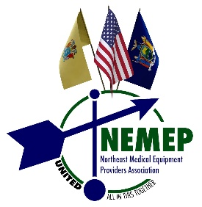

NEMEP Associate Member Benefit Levels
 | Gold  ($5,250) | Silver  ($3,150) | Bronze  ($2,100) | Associate  Membership ONLY  ($1,025)
Annual Meeting (Resume 2021)
Table at Annual Meeting (Hybrid) | 2 tables | YES | YES | NO
Annual Meeting Brochure Listing | YES | YES | YES | YES
May Present @ Annual Mtg (5min) | YES | NO | NO | NO
Sponsor & introduce 1 speaker at Annual Meeting | YES | NO | NO | NO
Educational Events

Ability to invite customers to VIRTUAL events at NEMEP member rate | YES | YES | YES | YES
Co-Sponsor VIRTUAL Educational Sessions | YES | YES | YES | NO
Co-Sponsor Webinar | YES | YES | YES | NO
Online Marketing

Sponsor Listing on NEMEP Website
Logo with link on NEMEP Website Home Page | YES | YES | YES | NO
Use of NEMEP Membership Listserv | YES | YES | YES | NO
Logo with link to your website in NEMEP Weekly Journal | On Request | Monthly | Quarterly | NO
Listing, logo in NEMEP’s email Journal | YES | YES | YES | NO
Mailings | YES | YES | YES | YES
Sponsor logo on all mailings

Feature ad can be included in member mailings and packets | YES | YES | YES | NO

